Careers and Placements Sustainability Statement

Careers and Placements, through the Green Impact environmental programme, has a Green Careers team to encourage everyone in Careers to be more environmentally aware and reduce our carbon footprint.

In 2023 we are once again aiming to gain the Green Impact Platinum, submitting evidence of our efforts towards environmental and sustainable status. Guided by the University’s Sustainability Plan and the UN’s Sustainable Development Goals (the three below, in particular).
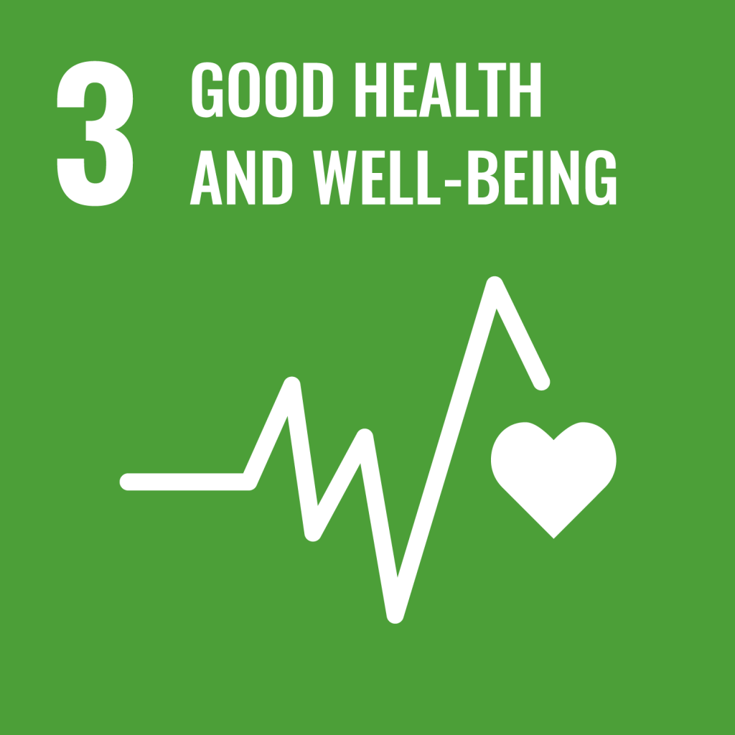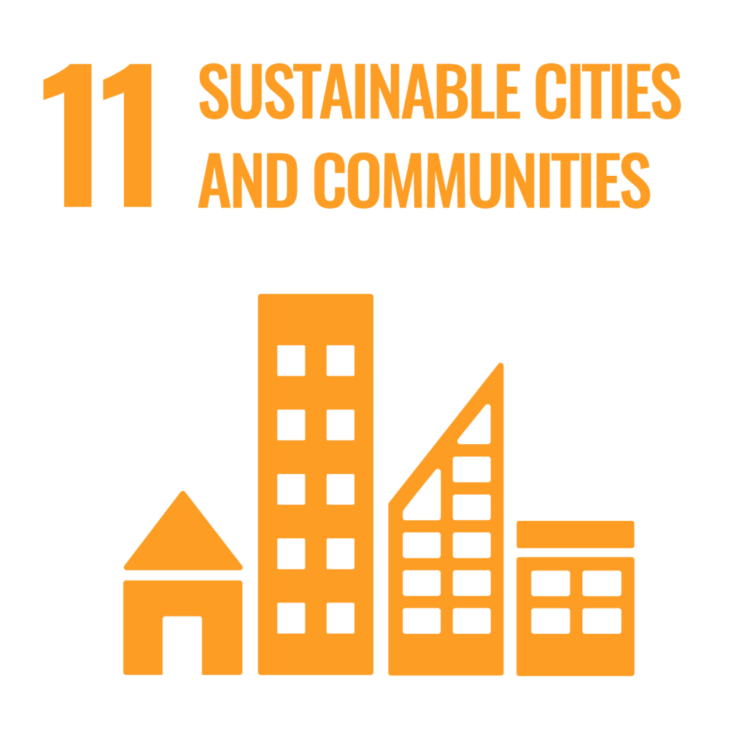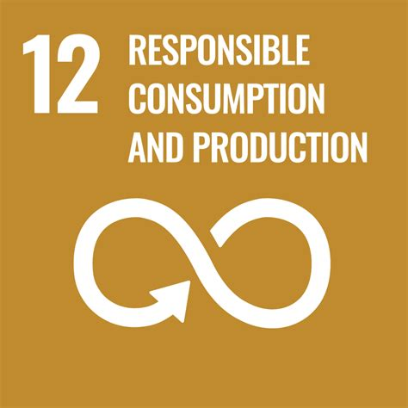
We:

- actively encourage recycling to avoid waste and to reduce the impact on the environment by having various recycling bins throughout the Careers Building

- endeavour to educate all staff to acknowledge the contribution they can make in saving energy such as turning off lights, computers, monitors and switching off the kitchen electrical equipment at the plug, when not in use

- organise charity events, such as the Macmillan coffee mornings, Save the Children Christmas jumper day, the Great British Bake Off Challenge, alternative Christmas card collection for a different charity each year, Sport Relief cake sale, toilet twinning, etc

- encourage staff to think before they print and to not take paper handouts to presentations, but to refer students to web links. We re-use paper as scrap paper that has been printed in error

- hold an annual swap shop after Christmas for people to bring in their unwanted gifts and swap with others. Spare unwanted items are donated to local charity shops

In addition:

- over half of our staff cycle or walk to work, and staff go for walks around campus at lunchtimes

